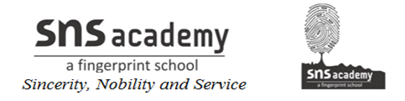

STD: IV SUB: SOCIAL

Lesson -10

I. Who am I?

1. I connect the state capitals of India.------------------------

2. I am the fastest means of transport.---------------------------

3. I carry goods on the seas and oceans.-----------------------------

4. I have been replaced by the mobile phones.---------------------------

5. I am a fast and the cheap means of communication.----------------------------

6. I am the national radio service of India.--------------------------------

II.The underlined word in each sentence is incorrect. Write the correct words.

1. Development in communication has enabled us to travel
from one part of the country to another in a few hours.-----------------------

2. The port of Kandla is in Odisha.

3. The perishable goods are transported by trains

4. We can buy inland letters from a police station.

5. Written documents can be sent through a xerox machine.

6. Radio is a means of transport.

III. Match the columns.

1. Shatabdi Express a. postal service
2. email b. road
3. Paradip c. train
4. national highway d. private radio channel
5. India Post e. port
6. FM f. Internet

IV. Write short answers

1. How did early humans travel?

--------------------------------------------------------------------------------------------------------------------------------------------------------------------------------------------------------

2. What are state highways?

--------------------------------------------------------------------------------------------------------------------------------------------------------------------------------------------------------

3. What do tanker ships carry?

--------------------------------------------------------------------------------------------------------------------------------------------------------------------------------------------------------

4. What is communication?

--------------------------------------------------------------------------------------------------------------------------------------------------------------------------------------------------------

5. How is cinema an important means of communication?

---------------------------------------------------------------------------------------------------------------------------------------------------------------------------------------------------------

